**Heroes of Pymoli – Game in-app purchase assessment**

This report analyzes the in-app purchases within “Heroes of Pymoli” by its user base. This assessment included purchases by 576 unique users who spent a cumulative of $2379.

Based on gender, males represented 84% of the purchasers. On individual purchases however, Females spent between $0.12 - $0.19 more than males (out of $3.20 average purchase) which is not significant. **Males are the clear leader in the purchasing category, responsible for $1967 out of $2379 total sales.**

When looking at age brackets, the cohort of 20-24-year-olds made by far the most purchases at 258, followed by 15-19-year-olds at 107 purchases. There is additional tail-off purchase behavior in the 25-29 and 30-34. **In general, the vast majority of purchases (602 out of 780) are in the 15-29-year-old domain and were responsible for $1819 (out of $2379) in total sales.**

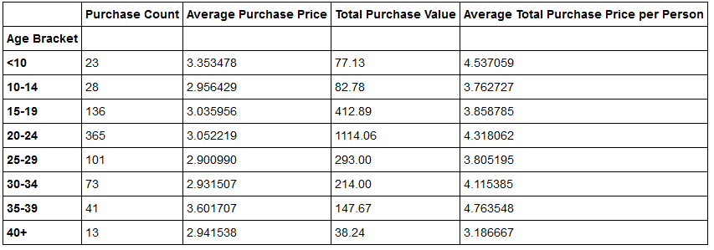

The top spenders in the cohort averaged 3-5 purchases. No customer showed > 5 purchases. As the prices for multiple product purchases are similar, **the top spending customers are highly correlated with the highest number of purchases.**

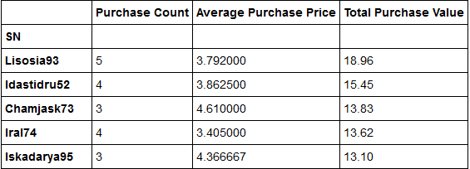

Examining the most popular and profitable items show several clear winners.

When looking at the highest number of purchases, **“Oathbreaker…”, “Firey…”, “Extraction..” and “Nirvana” make up the largest number of purchases at 9-12 purchases each per the table below.**

**Notably, lower-priced offerings (in the $1.xx range) were not top sellers by purchase counts.**

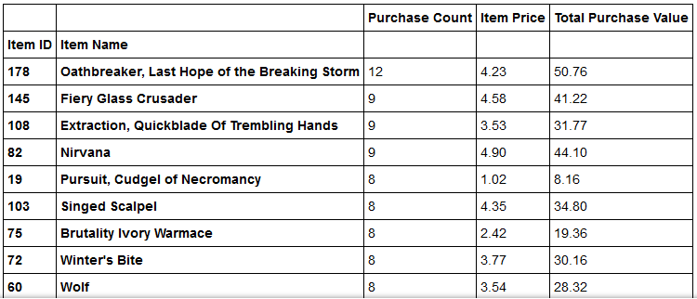

Examining the most profitable purchases, the list is quite similar when sorted by total revenue. Similar to the table above, **“Oath Breaker…”, “Nirvana” and “Fiery Glass Crusader…” remain the most profitable items.**

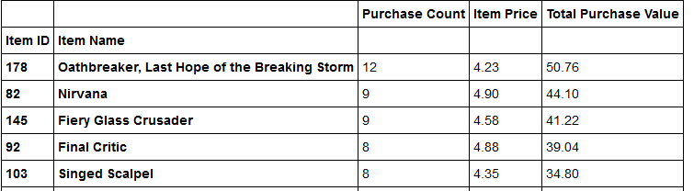

**Summary** – The dominant demographic of purchasers are males in the 15-29 age categories. The highest selling products (“Oath…”, “Nirvana” and “Fiery…”) are all priced in the > $4.50 price range. Recommend that future in-app purchase developments target the identified demographic and price ranges while providing features and usages similar to “Oath…”, “Nirvana” and “Fiery…”.